Rental Guidelines
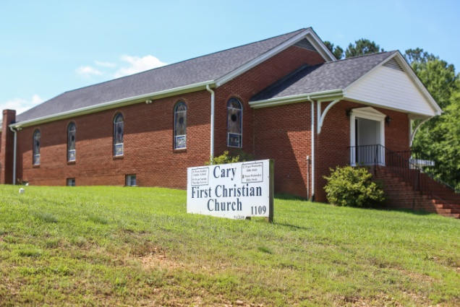
Events held at Cary First may include Worship Services, Bible Studies, Weddings, Funerals,
Meeting s, Dramas, and Workshops. Additional events must be approved in advance.

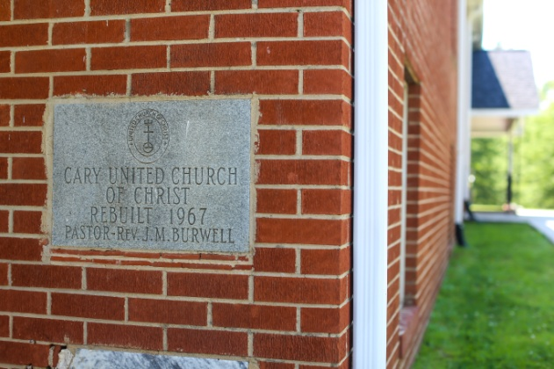
Weddings not performed by the Pastor of Cary First must be approved in advance. Individuals seeking to perform Wedding Ceremonies must be Ordained Clergy and must present a copy of Ordination Certificate.

Set-up and breakdown for the event, including decorations and scheduling of deliveries, should be approved in advance with Cary First coordinator. Cary First is not responsible for any items left on the premises. Items are not allowed on the premises overnight. Excessive items remaining after breakdown will result in additional cleaning fees.

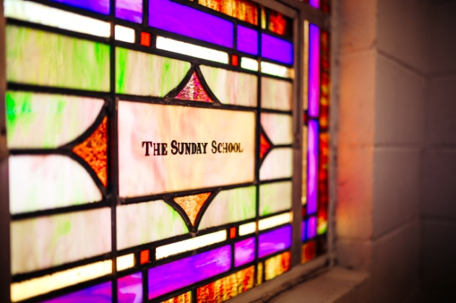
Additional use of the premise, including kitchen and classroom space, is available for an additional fee. One hour rehearsal time is included in rental fee. Desired rehearsal date and time should be communicated in advance and must be approved.

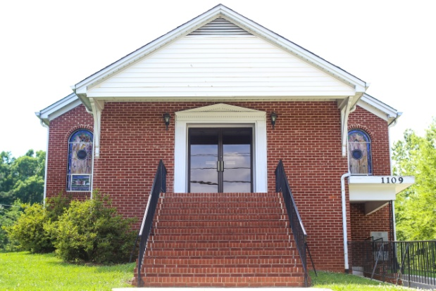
Decorations of any kind may not be adhered to the walls. Decorative items, including items adhered to pews and loose flower petals, must not leave permanent residue. Cleaning fees will apply for residue removal. Major removal of pulpit items is not permitted. Minor adjustments must be approved in advance.

Candles, including votives, tea lights, and other candle items, should have glass covered sides of minimum 1-inch coverage. Cleaning Fees will be applied for candle wax removal.

Please note: Loose glitter, birdseed, are sparklers are not allowed on Cary First property. Cleaning fees will apply if any of these items are brought on the premises.
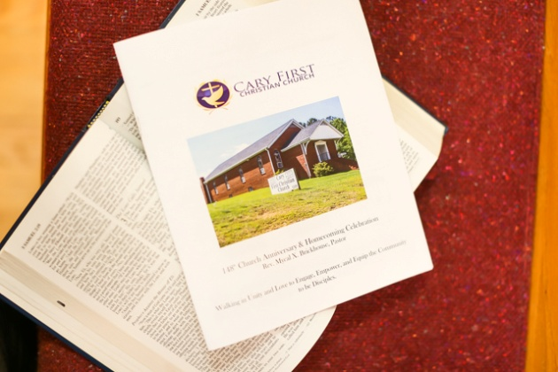
Entertainment, including any applicable licenses for live or recorded music, is the sole responsibility of the renter. Event music containing profanity and/or vulgarity is not permitted.
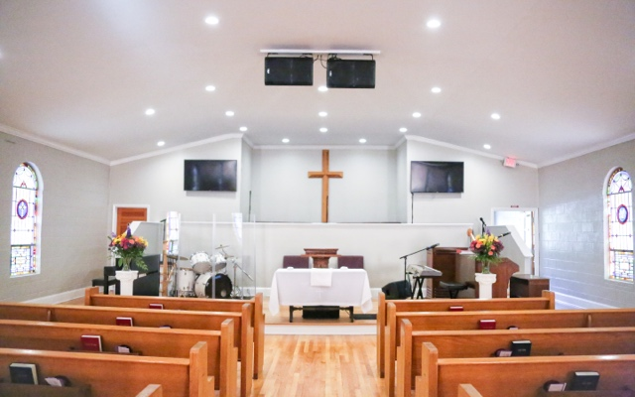
Photography and videography are allowed in the sanctuary but are not permitted in platform or on any instrumental equipment.

Smoking is not permitted on Cary First property at any time.

Alcohol is not permitted on Cary First property at any time.

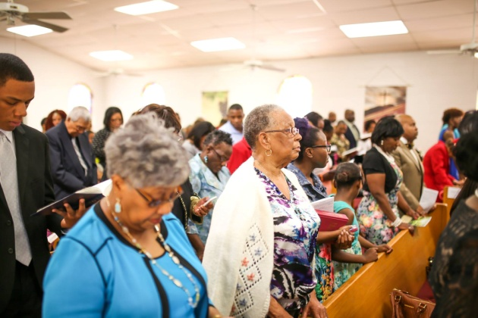
Audio Visual Equipment, including microphones, projector, and projector screens, may be used during the scheduled event time. Use of instrumental equipment owned by Cary First must be approved in advance. Audio visual technician is required for an additional fee.

Event Parking is available in the Cary First parking lot and adjacent street (Silvergrove Road). Additional parking on Cary First property must be approved in advance.

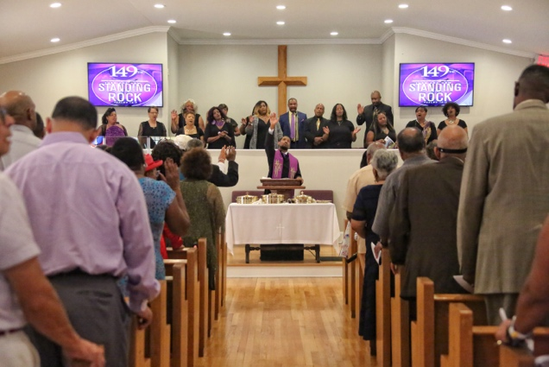
Damages of any kind will result in the forfeiture of the damage security deposit.

Acts of God that cause any failure of performance shall not be the responsibility of either party and in such case Cary First will make every effort to reschedule the event. If the event cannot be rescheduled, Cary First will refund the amount minus the non-refundable deposit.

Cancellation by the renter shall be at least 14 days prior to the event. Cancellation less than 14 days will result in the forfeiture of the deposit.

Rental Fees

Cary First Sanctuary
Cary First Sanctuary is available for renting. Complete with stained glass windows, the sanctuary offers seating for 250 guests. Projector screen, projector, and microphones are included in the rental. Instrumental equipment, including piano, organ, and drum, is also available upon approval.

Cary First Fellowship Hall
Cary First Fellowship Hall provides seating for 80-100 seated guests. Tables are included in rental.

Events
Cary First Sanctuary $300.00
Cary First Fellowship Hall $300.00
Meetings
Cary First Sanctuary $75.00 per hour
Cary First Fellowship Hall $75.00 per hour

Damage Security Deposit
Refundable Deposit $150.00

Additional Fees
Audio/ Visual Technician $50.00
Removal of candle wax from carpet $50.00
Carpet Stain Removal $25.00
Custodial Services Available Upon Request

*50% Deposit is required with Contract for Event Reservation. Remaining balance is due 14 weeks prior to event.
**$150.00 Refundable damage deposit is due at the time of reservation.

